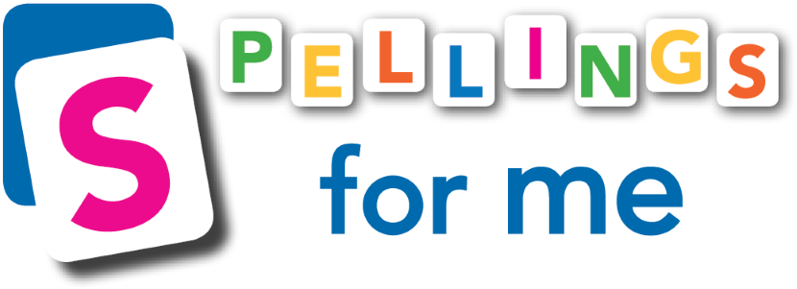
www.spellingsforme.ie info@spellingsforme.ie 01-5351661

2024/2025 Order Form

- The Spellings for Me workbook costs €9.50 per child. With this, the child will gain access to their online profile for free.
- This would replace the child's current traditional spelling workbook.
- The number of workbooks purchased will equal the number of online student profiles unlocked for your school. This number will lock on your online account.
- If you would like to add extra students after the initial order, simply email us at info@spellingsforme.ie and we can look after this for you.
1. School Name:
2. Roll Number:
3*: Number of Workbooks to be delivered per standard:  See note on page 3 ‘Choosing a Workbook’. | 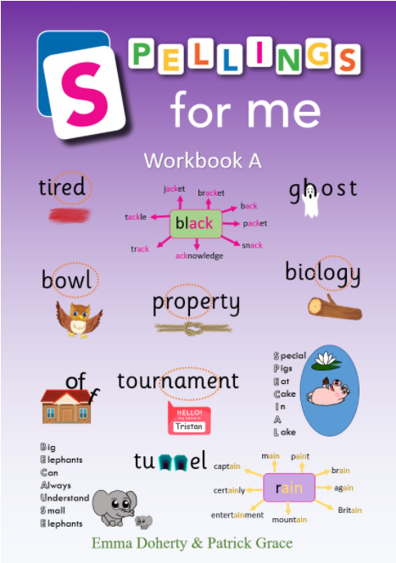 | Workbook A  Click here to view Workbook A | Total number of Workbook A required:
 | 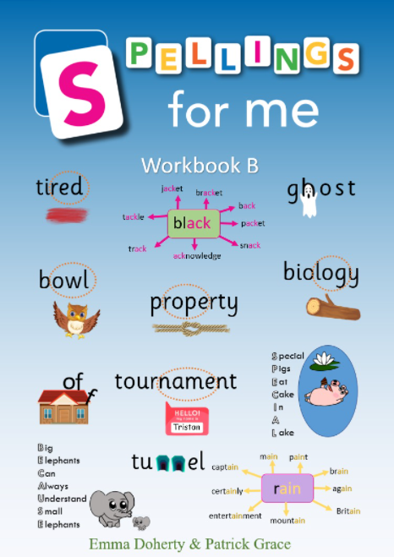 | Workbook B  Click here to view Workbook B | Total number of Workbook B required:
 | 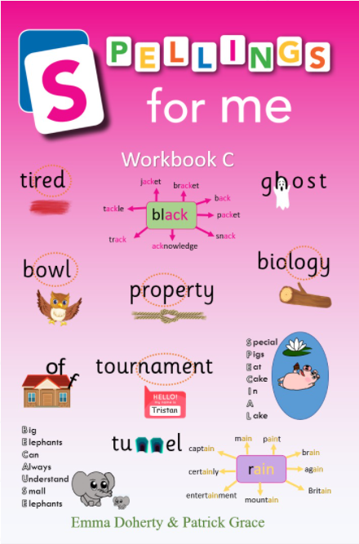 | Workbook C  Click here to view Workbook C | Total number of Workbook C required:
 | 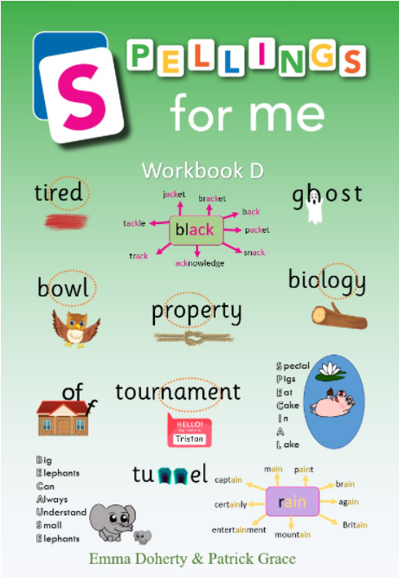 | Workbook D  Click here to view Workbook D | Total number of Workbook D required:
 | 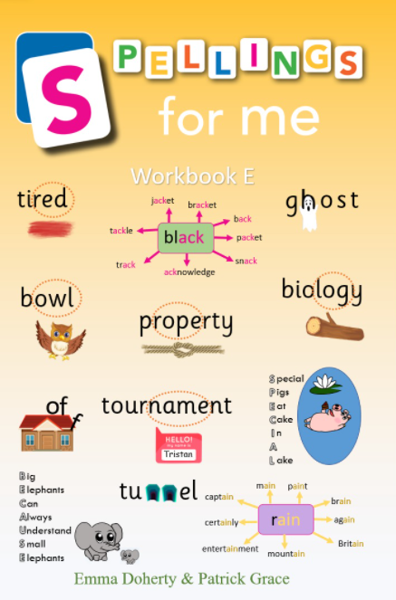 | Workbook E  Click here to view Workbook E | Total number of Workbook E required:
 | 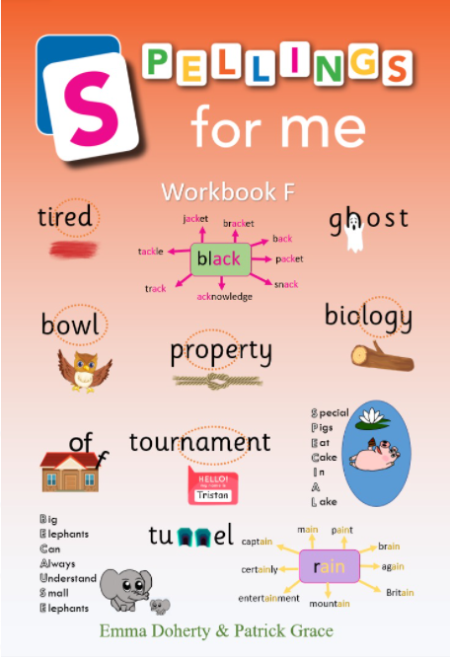 | Workbook F Total number required:  Click here to view Workbook F | Total number of Workbook F required:

4. Total Number of Workbooks Required: (€9.50 per workbook)
5. Delivery Address:

6. Eircode: (Required)

7. Delivery Options  Workbooks will be delivered by courier ON the date selected.  Drag circle over selected date or highlight. | - Immediately- within 5 working days  - 23rd May  - 7th June  - 26th June  - 29th August  - 2nd September  (Orders processed after 1st September will be sent out within 5 working days)
8. Total Cost:  Delivery is free for a full class set (20 workbooks) A delivery charge of €5 will be added for orders less than 20 workbooks. Please include a delivery fee if applicable. | €
9. Telephone Number:

10. Your Email Address:

11. Ordered by:
(Name and position in the school)
12. Email address invoice is to be sent to:
13. Do you already have an account with Spellings for Me? Drag circle over your answer. | yes no
If yes, what is your School Personal URL?

14. I want Spellings for Me to set up/organise the students and teachers in my school. Drag circle over your answer. | yes no

As you can see the workbooks are not called 1st class, 2nd class, 3rd class, 4th class, 5th class or 6th class.
Teachers should look through the workbooks- looking at the types of games/activities and decide what is suitable for their class maturity level.
A strong speller and a weak speller in the same class can use the same workbook. The differentiation comes from the online profile.
E.g. Workbook A may be suitable for a 1st class or a 2nd class. It could also be used for a young 3rd class.
Multi class teachers: You can order the same workbook for your whole class. The online profile will provide differentiation according to their ability.
Choosing a Workbook
Workbook A | 6 year olds  12/13 year olds
Workbook B

Workbook C

Workbook D

Workbook E

Workbook F

Administration:
*If you would like Spellings for Me to set up/organise students and teachers in your school, please fill out the information below. Please leave blank if you will do this yourself.
Set up is free. We recommend sending us this information before the summer break as wait times can be longer in September. It does not have to be sent in with the order form and can be sent at a later date.
15.A Student Profiles/ Class Lists
If you wish to add new children to the programme, please provide a class list. Please include the standard and class teacher’s name.  (E.g., The title of the list could be ‘4th Class 24/25- Mr James Barry’) | You can attach this separately in your email.  Please ensure that we can copy and paste from this attachment. E.g., Excel file, Aladdin file, Word document etc.

15.B Important: Students and teachers already uploaded to Spellings for Me will keep these same accounts year after year. They do not need to be uploaded again as this would result in duplicated users. Fill in the relevant information below and we will move these children on to their next class folder with the appropriate teacher. See example in Line 1.
Leave this section blank if this is not applicable to your school.
If you would like to do this yourself, please find instructions linked here.
You can also watch a useful YouTube video linked here.
Class Folder & Teacher 2023/24 (Last year) |  |  | Class Folder & Teacher 2024/25  (Forthcoming year)
3rd Class 23/24 | Mr John Smith |  | 4th Class 24/25 | Mrs Mary Doyle

Special Requests:

16. Teacher Profiles:
If you would like us to create teacher profiles, please fill in the grid below.
Note: We need individual, accurate email addresses for each teacher. This is how we communicate login details. Please do not provide the same email address for every teacher.
If teachers already have an account with us, you do not need to fill in their information below.
Teacher Profiles to be Created
First name | Surname | Email address | Class

17. If you would like us to delete users, please send us a list of pupils to be deleted. You can also do this yourself by following the instructions linked here. Teacher profiles can also be deleted.
Please email this form to info@spellingsforme.ie in Word format.
Thank you!
If you have any questions or need assistance with this form, please do not hesitate to contact us.
www.spellingsforme.ie info@spellingsforme.ie 01-5351661

